Computer Language Coding Concepts

System Object in a Diagram
The concept of system objects is explained in the article System Objects. The current article only explains its expression in a diagram.

System objects are displayed in a diagram as the system interface of the target object.

Normally, when an object has several interfaces, each interface is drawn out as a triangle, contained by the object:

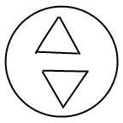

The complete notation for interfaces is explained in later articles. The system interface uses an alternative notation for an interface. The system interface is not part of the target object, but part of the object reference representing the target object. A symbol closely represents an object reference, rather than a specific object, therefore, the triangle of the system interface is stuck to the border of the symbol:

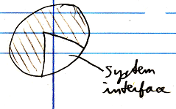

That way the interface is more part of the symbol, than part of the object.

To make more room inside the system interface, sometimes the following an exaggerated notation is used:

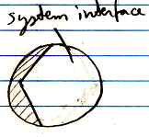

Normally, the system interface is not shown. Normally, the contents of the target object are shown inside the symbol.

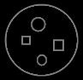

Showing the system interface is like breaking open the object reference to see its internal workings to adapt its configuration.

When the system interface is shown, the contents of the target object may not be shown inside the symbol anymore.

A system interface is the new computer language’s equivalent of Getters, Setters and Property procedures.

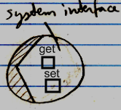

As such, all members of the system interface will all be displayed inside this triangle, stuck to the border of an object symbol.

A square is the symbol for a command. You will see command symbols in the system interface, even though the topic of commands has not been covered yet. Commands will be further explained in the Command articles.

See also: System Objects

Author & Copyright: Jan-Joost van Zon Date: July 18, 2008 – July 23, 2008 Location: Oosterhout, The Netherlands Status: Finished

